1) GET - /info - Retrieve the application details in the following format

"App Name: " + appName + ", Version: " + appVersion

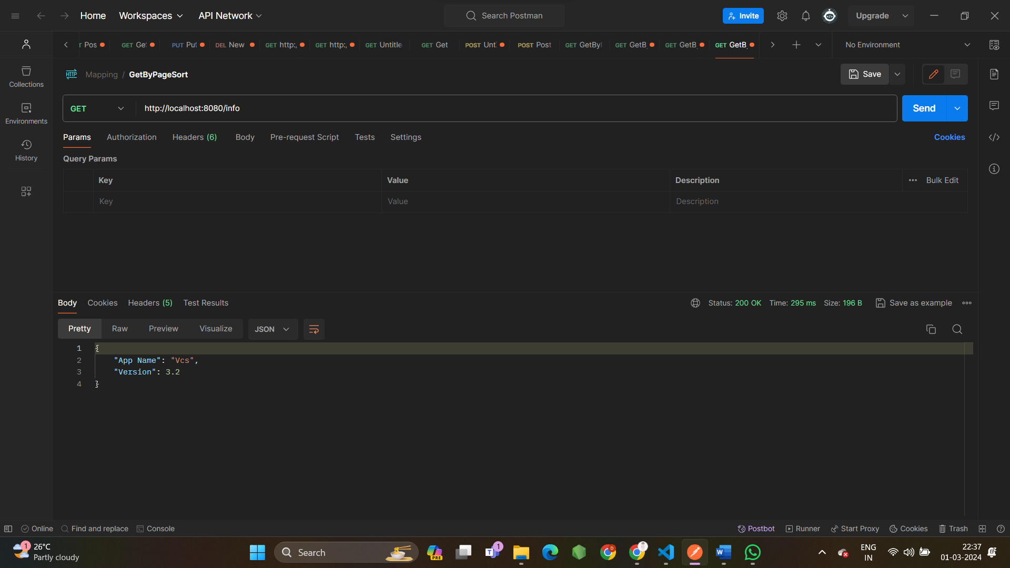

2) POST - "/students"

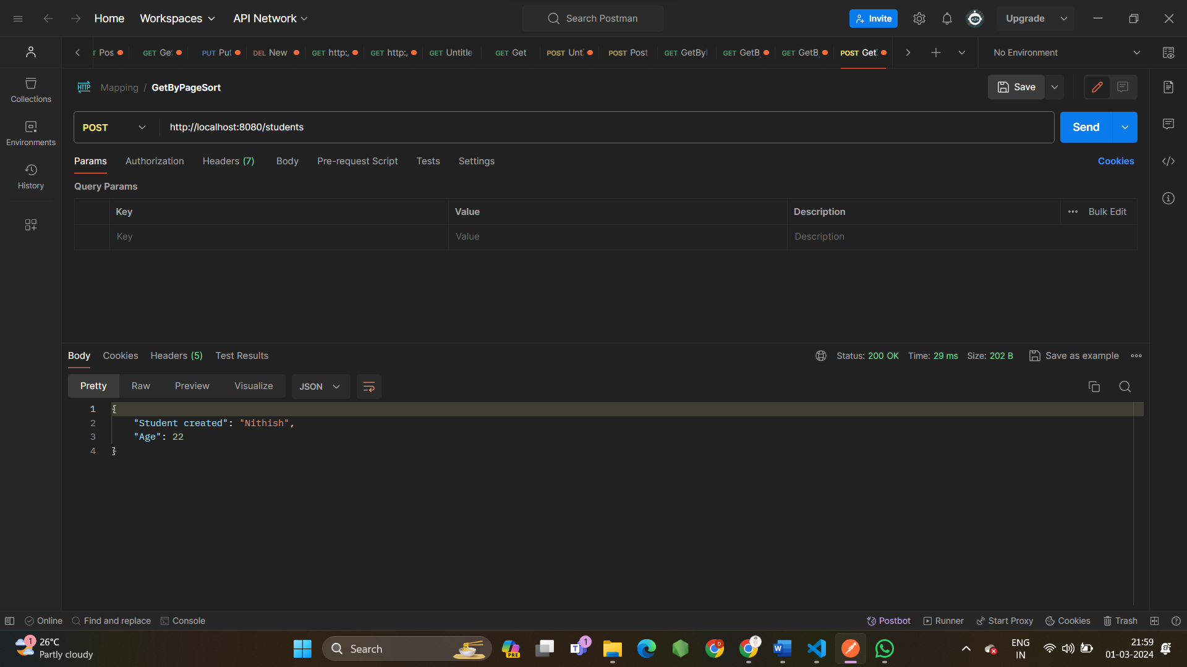

3) - /student - retrieve the student object

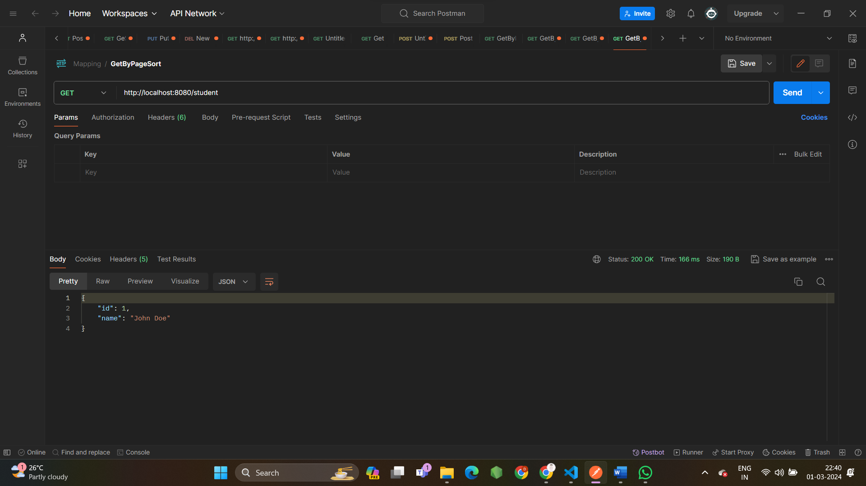

4) GET - /book - Retrieves the book object.

